DISTANCE VS. TIME LAB
Materials:
Papers
Pencils
Motion detector
Procedure:
Develop a position vs. time story that describes a body in motion. Then create a position vs. time graph to illustrate the story, including the directions for following the story underneath.
Steps of the story:
- Start walking to the bathroom 3 meters: 6 seconds
- Accelerate to arrive in time to pee 3 meters: 3 seconds
- Go to the bathroom 0 meters : 24 seconds
- Run back 3 meters: 3 seconds
- Walk back the rest of the way 3 meters: 6 seconds
Graph:
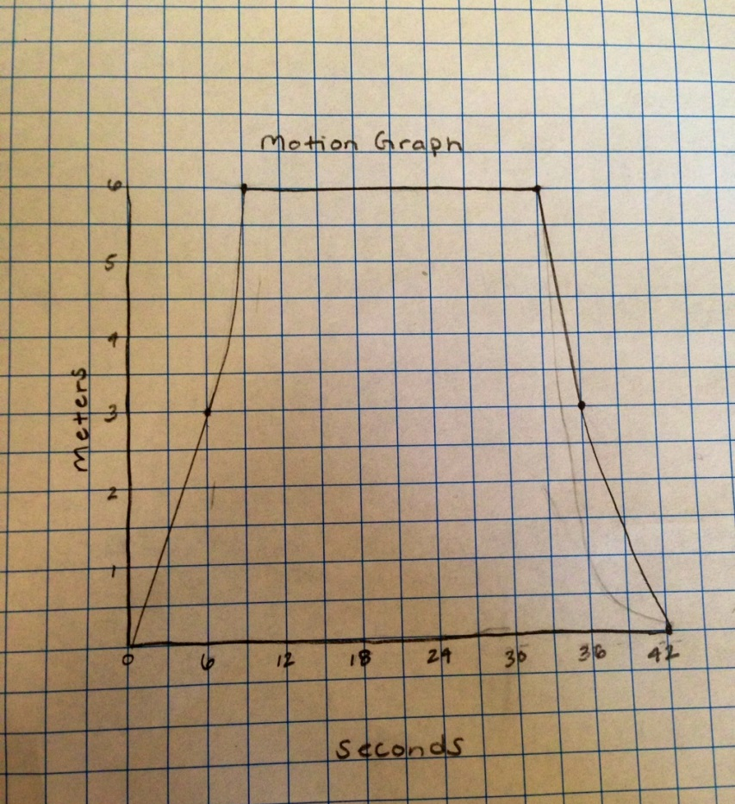
Using the motion detector:
Using the motion detector act out the story at a scale of 1/3 what the story tells and then show the graph it creates.
Graph:
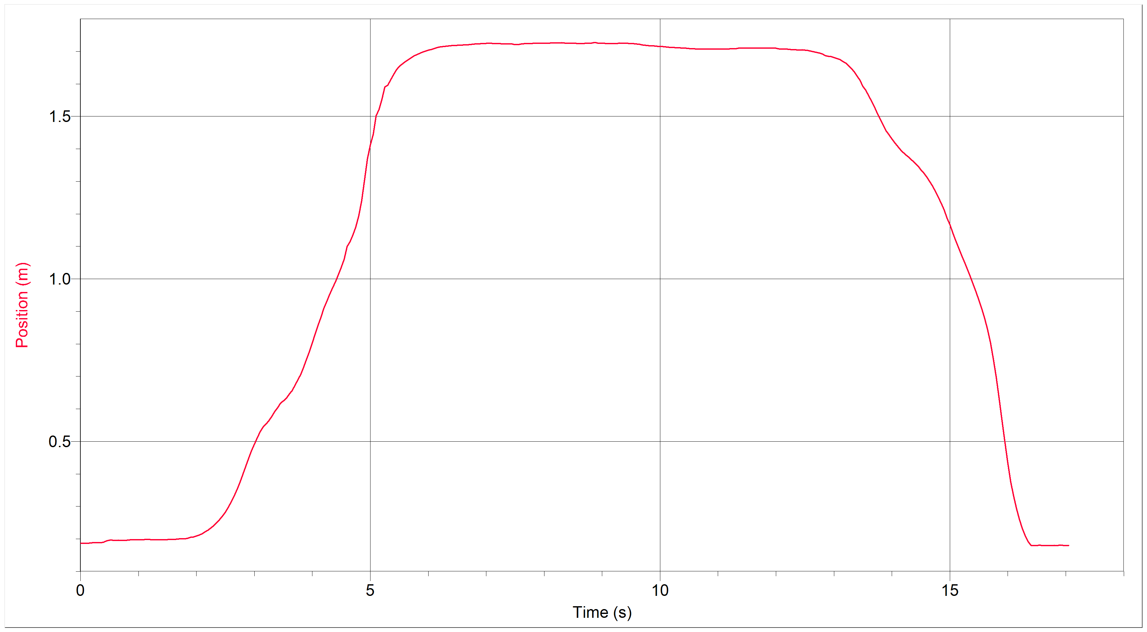
Data Analysis:
They were roughly the same but due to human error during the production of the motion detector graph.
Conclusion:
This lab introduced us to how we use the motion detector and how to accurately read a displacement vs. time graph. We also succeeded in closely matching our motion graph with the one we drew showing the expected resulting graph.

