Bruce Moshier
Ms. Geddes
AP Physics
September 27th, 2013
Projectile Motion Lab

Projectile Motion: Angry Birds

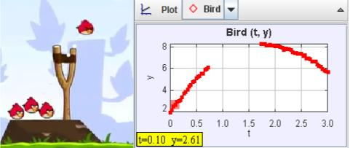

In the game Angry Birds, birds are shot from a slingshot. Does their motion follow the principles of projectile motion? We can use video analysis to answer this question.
When we do video analysis, we chose an item in the video to use as a reference to determine distances (how many pixels equals 1 meter, for example). In the case of Angry Birds, instead of scaling the video with a known object on the screen, we can scale the video by the acceleration due to gravity, assuming the Angry Bird world is the Earth.

Begin by downloading the following files:
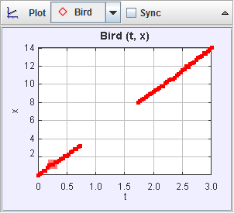
- angry_bird_short.mov
- angry_bird_projectile.trk

The “trk” file is a partially marked Tracker file and if you double click it (and Tracker is installed), it should launch a tab in Tracker (it will likely ask you where the video file is and you will have to point to where you downloaded the mov file). Play the video and notice that the “camera” moves to follow the bird and that the window changes size.

In order to track the bird, we will need a fixed origin (the slingshot) and since the origin goes off screen, we need an offset point (the distance from the slingshot to a blade of grass that shows up for most of the trajectory of the bird).

We also need a set length since the movie zooms in and out. It turns out that the height to the fork of the slingshot is the same as the height of the pedestal the pig sits on. We will establish this height as “1” in “trk” file. Now, even as the image zooms and pans, the length of the pig’s pedestal is always “1” and the location of the origin is set. DO NOT adjust the “Coordinate Offset” or the “Calibration Stick” or the data will no longer account for the movement of the camera or the zooming in and out on the screen.

The“trk” file already has the position of the angry bird marked. The track of the marked points is not a parabola on the video. Why not?

Because it is an x vs. t graph and the velocity of x does not change, and this means that the graph won’t curve.

The plots of x vs. t and y vs. t match more closely with what you might expect for projectile motion. Sketch the plot of x vs. t below:

Explain why some points are missing:
The bird goes off the screen during the video, and because of this it can’t be tracked, causing a straight line.

Explain why the plot is a straight line:
Because there is constant zero acceleration.

Now, sketch the y-position data as a function of time (click on the vertical axis label “x” and change it to “y”).

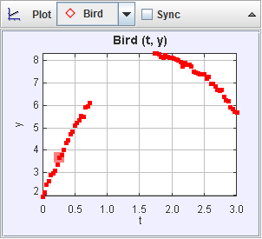
Why is it parabolic (or would be if there weren’t missing data)?
Because there is constant negative acceleration counteracting the positive velocity, which results in a parabola.

Now, we are going to fit the data of the position versus time graph. Right-click on a plot (graph) you want to fit (y versus t for one of the masses) and choose Analzye:

A new window opens up with the title Data Tool. Click the Fit check-box and then, because the graph is parabolic, pick Fit Name -> Parabola:

Record the following:

a | -1.882
b | 6.833
c | 1.993

These coefficients correspond to the equation of the form:
y = at² + bt + c

Now, when two other students, Pat and Jordan, previously fit their data, they got the following (this is not the data you will get, it is simply an example):

a | -4.8
b | 3.0
c | 1.2

Taking the above information and transforming it to the book’s notation, their equation of motion would be the following:

y = 1.2 + 3.0t – 4.8t²

For the previous example with Pat and Jordan’s data, (assuming that the ball has just left the hand at t = 0) what is the equation of the velocity in the y-direction (differentiate the equation of displacement):
$$y^{'}=-9.6t+3$$

What is the vertical velocity right after the ball left the hand of the person throwing in this example?
3

Q1. Pat and Jordan’s measured initial vertical velocity is
A. 1.2
B. 3.0
C. -4.8
D. -9.6
E. -9.8
F. none of the above

For this example, what is the equation for the acceleration for Pat and Jordan’s data (second derivative of position function)?

-9.6

Q2. Pat and Jordan’s measured acceleration is
A. 1.2
B. 3.0
C. -4.8
D. -9.6
E. -9.8
F. none of the above

Now, back to your data.

What is your equation of motion?

y = $-1.882t^{2}+6.833t+1.993$

Differentiating this, what is your equation for the velocity as a function of time?

v_{y} = 3.764t + 6.833
What is the “initial” velocity in the y-direction (velocity leaving the sling shot)?

v_{0y} = 6.833

What is the acceleration (from your data)?

a_{y} = -1.882

You should not get a value of -9.8 or anything close to that because your acceleration is in units of pig pedestal/second². Why is that your unit instead of m/s²??
Because we’ve established all units of distance in pig pedestals, but we’ve left our unit of time in seconds.

If we assume the acceleration due to gravity is -9.8 m/s², what is the conversion for pig pedestal units to meters? For example, if Pat and Jordan found (with different data from above):

a_{y} = $-1.882 pig pedestals/s^{2}$

Then they know that
1.882 pig pedestals= 9.8 m or
1 pig pedestal = 5.207 m

What is your conversion between pig pedestals and meters?

1 pig pedestal = 5.207 m

Your “measuring tape” is calibrated to pig pedestal units. Click on your measuring tape (Tape A) to measure the following (click on an end to adjust the length):

How many pig pedestal units tall is the sling shot?

1.801
How many meters is that?
9.378
How many pig pedestal units is the angry bird?
.309

How many meters tall is the angry bird?
1.609

Is that a big or small bird? Explain.
They are very large as your average bird doesn’t get more than a couple feet long.

From your tracker data, what is the initial
y-velocity of the angry bird in m/s (instead of pig pedestal units/s):

v_{oy} = 35.579 m/s

Now, go back to the graph of x versus time and fit the x-position data to a line (instead of a parabola):

x-position equation:

x = _____________________

What is the initial velocity in the x-direction?

v_{0x} = __________________pig pedestals/s

What then is the initial speed of the launch from the sling shot (magnitude of the initial velocity vector)?

a | 1.350
b | 3.970

(from x = a*t + b)

x-position equation:

x = 1.350t + 3.97

What is the initial velocity in the x-direction?

v_{0x} = 3.97 pig pedestals/s
and in meters/s:

v_{0x} = 20.672 m/s

What then is the initial speed of the launch from the slingshot (magnitude of the initial velocity vector)? 41.148 m/s

Based on this analysis, what can you conclude about the motion of the birds in Angry Birds?

It can be considered to follow the same rules of projectile motion as those in reality. Though the birds and pigs in them are quite large.

Inspired by Rhett Allain’s DotPhysics blog for Wired Magazine: “The Physics of Angry Birds,” Oct 8, 2010. http://www.wired.com/wiredscience/2010/10/physics-of-angry-birds/ and by Frank Nochese’s Action-Reaction blog, “Angry Birds in the Classroom,” http://fnoschese.wordpress.com/2011/06/16/angry-birds-in-the-physics-classroom/ (accessed Nov 21, 2011).

